**PLEASE REFER TO THE SELLER INFORMATION FLYER FOR INSTRUCTIONS ON DOWNLOADING THE SCOREBOARD APP AND ORDER ENTRY PROCEDURES.**

**THANK YOU!!**

**THANK YOU FOR YOUR SUPPORT!**

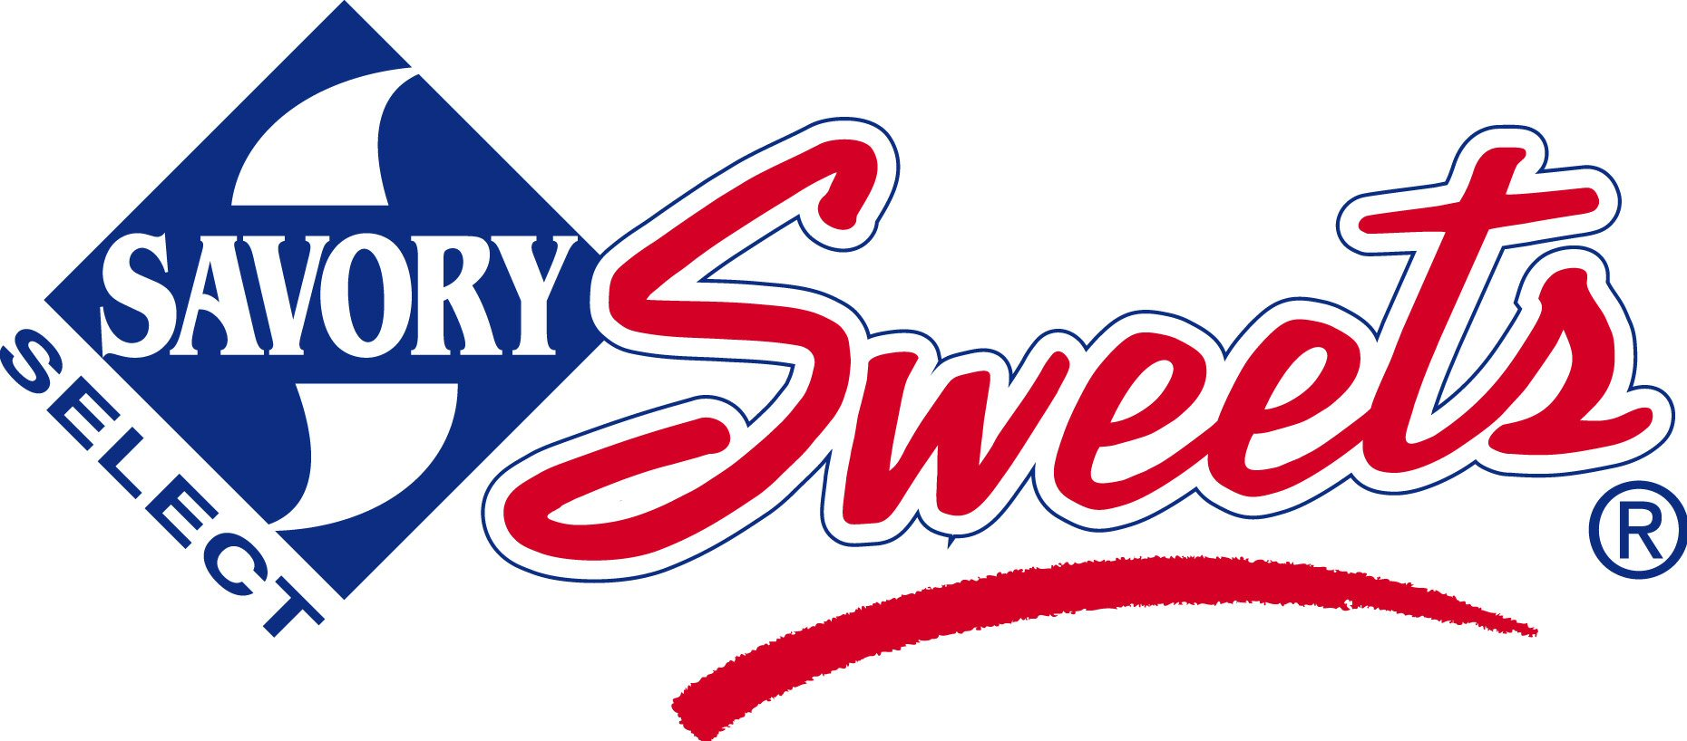

We are pleased to offer **Savory Sweets Home Style Cookie Dough and Lava-licious Fudge Cakes, Chocolate Dipped Pretzels and Gourmet Caramel Corn** for our current fundraiser!

All of these delicious products are Proudly **MADE IN GRAND RAPIDS MICHIGAN!!!**

**VIRTUAL SALE BEGINS:**

**VIRTUAL SALE ENDS:**

**ORDER TO BE DELIVERED WEEK OF: SPECIFIC DAY AND TIME TO BE COMMUNICATED.**

Questions? Contact:

**PRICES**

Home Style Cookie Dough and Gourmet Chocolate Lava Cakes

**$19.00 each**

**PLEASE HELP ME TO REACH**

**MY PERSONAL GOAL OF: 20 items**

**TIPS!**

Share the brochure in the App with family & friends!

Smile & identify yourself and your group!

Stay safe when selling; never go to a stranger’s house!

Always say “Thank You!”

**The money we raise will help us purchase classroom supplies, playground equipment and more!**